June 9, 1916
Responsibilities of a Husband and Wife: A Quranic perspective
I bear witness that none deserves to be served besides Allah and I bear witness that Muhammad is the servant and messenger of Allah.
After this, I seek the protection of Allah from the accursed devil.
In the name of Allah, the Beneficent, the Merciful.
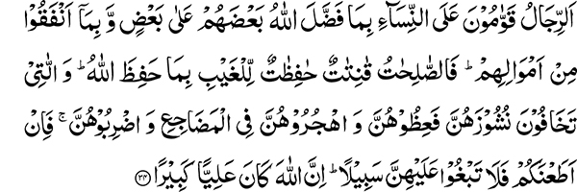
Men are the maintainers of women, with what Allah has made some of them to excel others and with what they spend out of their wealth. So the good women are obedient, guarding the unseen as Allah has guarded. And (as to) those on whose part you fear desertion, admonish them, and leave them alone in the beds and chastise them. So if they obey you, seek not a way against them. Surely Allah is Ever Exalted, Great. (4:34)
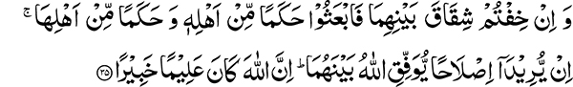
And if you fear a breach between the two, appoint an arbiter from his people and an arbiter from her people. If they both desire agreement, Allah will effect harmony between them. Surely Allah is ever knowing, aware. (4:35)
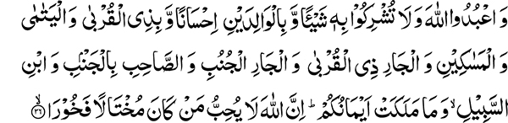
And serve Allah, and associate naught with him, and be good to the parents and to the near of kin and the orphans and the needy and the neighbor of (your) kin and the alien neighbor, and the companion in a journey and the wayfarer and those whom your right hands possess. Surely Allah loves not such as are proud, boastful. (4:36)
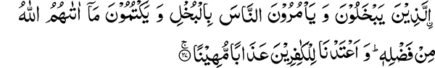
Who are niggardly and bid people to be niggardly and hide that which allah has given them out of his grace. And we have prepared for the disbelievers an abasing chastisement — (4:37)
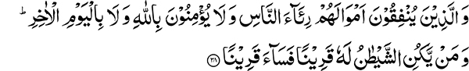
And those who spend their wealth to be seen of men and believe not in Allah nor in the last day. And as for him whose companion is the devil, an evil companion is he! (4:38)
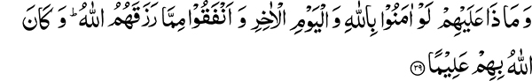
And what (harm) would it do them if they believe in Allah and the last day and spend of that which Allah has given them? And Allah is ever Knower of them. (4:39)
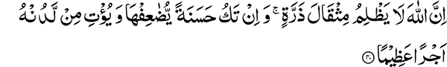
Surely Allah wrongs not the weight of an atom; and if it is a good deed, he multiplies it and gives from himself a great reward. (4:40)
But how will it be when we bring from every people a witness and bring thee as a witness against these? (4:41)
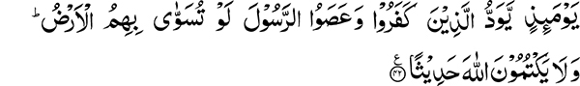
On that day will those who disbelieved and disobeyed the messenger desire that the earth were leveled with them. And they can hide no fact from Allah. (4:42)
Men are maintainers of women. What is the meaning of being maintainer (qawwam)? There is a word qaim in the Arabic language. Qawwam is the exaggerated form of this word. It means one who frequently stands up for something or is the maintainer of someone.
Qama-l-rajulu ‘ala-l-mar’ati means he maintained her and managed her affair, having charge of her affair; hence he is said to be her qawwam, i.e., maintainer. Similarly, qama bi-l-yatimi means, he maintained the orphan.
Hence by the men being qawwamun is only meant that they are the maintainers of women with that which Allah has made some to excel others.
What are the needs of women for which they need maintenance? These include food, clothing, shelter, household equipment, furniture etc. Men also are their maintainers in religious matters and have the responsibility to provide them with information in this regard. If there is a shortcoming, it is their duty to help correct it. It is an established principle that an administrative unit consisting of two or three persons cannot be run efficiently without giving a higher level of authority to one over the other. Men are maintainers of women in the relationship Allah the Most High has created between them.
Limitations of Women
A serious limitation that women have to face is the lack of time to be the breadwinners of the family because of their household and child rearing responsibilities. They do not have the time or the physical stamina to carry out all these tasks. Allah the Most High has endowed men with stronger physical capabilities so that they can earn for themselves and the upkeep of women. That is the reason why Allah the Most High has given them the responsibility of being maintainers of women. The Holy Quran expresses this in these words:
With what Allah has made some of them to excel others and with what they spend out of their wealth.
Inappropriate Attitude of Men
Men are responsible for the physical sustenance of women. The responsibility of providing spiritual and moral sustenance also rests upon their shoulders. This character building, however, cannot be accomplished by forceful means. Men are ready to be the maintainers of women, but are unwilling to be their role models for character reformation. You need to understand that by being maintainers of women you are not to become a source of distress by repeatedly punishing them for minor disagreements or cutting of relationship and leaving them in a state of suspense. Qawaam implies, providing for their wellbeing. This cannot be accomplished by use of force but through moral example and teachings. In the matter of faith, the onus of responsibility for providing the correct guidance lies with men. If a housewife fails to put the right amount of salt in the food some men lose their temper and even become violent. On the other hand they choose to remain silent if the women break some religious covenants. The result of their unfamiliarity in religious matters and behavior contrary to the path of righteousness has an impact upon their children. As a result the moral fabric of the whole society is affected. It is absolutely essential for women to learn about their religion. They are most of the time unaware or carefree of this responsibility. For example much is said about the giving of zakaat (obligatory charity). Most men have the attitude that they do not care to inform the women about this. People consider the collecting of zakaat a difficult task because the collection involves a third party. There is no doubt that some difficulties exist but in many cases you are empowered to do so and it can be easily accomplished. Man can accomplish everything by overcoming difficulties. The truth is that our women lack the proper knowledge otherwise they would have no reluctance in paying the zakaat.
Excellent Example of a Believer
One of our highly respected friends has made an attempt to collect zakaat. He collected zakaat from all the women in his household, including his daughter- in-law who was married just a few days ago. He is our venerable friend Khawaja Kamal-ud-din. This task was after all accomplished by his verbal reminder. Why can others not try to follow his example? I have mentioned this as a good example to be followed. Those who do not give the proper advice to their women are at fault. Women can be considered handicapped to some degree in this matter because of their unfamiliarity with the subject. You who are informed and familiar with the tenants are the ones really at fault and accountable.
Why have men been made maintainers of women? The Holy Quran informs us:
With what Allah has made some of them to excel others and with what they spend out of their wealth.
Allah has made some of them to excel others so that men spend their wealth for the women and provide for their subsistence. This is why Allah has given them a degree above in the decision making process.
Exemplary Wife
Holy Quran describes the exemplary character of a wife in these terms:
So the good women are obedient, guarding the unseen as Allah has guarded.
This means that they guard the rights of their husbands. Their three qualities are described as righteousness, obedience to God and guarding the unseen. They are told to safeguard the rights of the husband because Allah the Most High has safeguarded their rights. Women in Islam had not demanded any rights in fact they could not even imagine that they had any rights. Allah the Most High states, He has given these rights to you in the Holy Quran without you asking for them. Since Allah has protected the rights your husband’s owe you, in return you should also be the ones who protect their rights.
Reformation of the Wife who manifests Unrighteous Conduct
It is then stated regarding some women:
And (as to) those on whose part you fear desertion
Nushuz or desertion on part of the wife means the wife resisted the husband and hated him and deserted him.
In verse (4:128) the nushuz of the husband against the wife is mentioned in these words:
And if a woman fears ill-usage from her husband or desertion.
Here the husband is at fault and subjects the wife to physical abuse.
The verse under discussion refers to the circumstances when the wife is at fault. Under these circumstances three remedies are proposed:
And (as to) those on whose part you fear desertion, admonish them, and leave them alone in the beds and chastise them.
The first is guiding and counseling, if these measures are unsuccessful, a limited separation in terms of withholding conjugal relations is advised. If they still do not desist from their behavior, mild chastisement is allowed. People have the tendency to quickly adopt a behavior that is in consonance with their own disposition. The third tier remedy of mild chastisement that Allah the Most High has permitted is readily taken up without giving attention to the first two. The type of chastisement allowed is decidedly of a mild nature and certainly not one causing injury. Imam Shafi says that although mild chastisement is permissible, it is best to avoid it. Contrary to this women are severely rebuked for minor disagreements with their husbands.
Taking Undue advantage of being given the Upper Hand
Human nature is diverse. Sometimes a hint is all that is needed for a person to do the right thing. The Holy Quran has given this commandment:
And women have rights similar to those against them in a just manner, and men are a degree above them. And Allah is Mighty, Wise. (2:228)
This does not mean that men should take undue advantage of being placed a degree above the women and go about beating them. In the early days of Islam the companions of the Holy Prophet who had migrated with him from Makkah (the muhajireen) were harsher in their treatment of women. As the rights of women were established their women became more aware. When a certain individual treated his wife harshly, the next day seventy women came to complain to the Holy Prophet. In his sermon, on this occasion the Holy Prophet severely rebuked those who ill-treated their wives. According to another hadith, “the best of you is he who is best to his wife.”
The Holy Quran also states in (4:19):
And treat them kindly.
The Goal should be Reformation
After these three proposed solutions it is stated:
So if they obey you, seek not a way against them. Surely Allah is Ever Exalted, Great.
Then a general rule is laid down:
And if you fear a breach between the two, appoint an arbiter from his people and an arbiter from her people. If they both desire agreement, Allah will effect harmony between them. Surely Allah is Ever Knowing, Aware.
In a different passage of the Holy Quran, it is stated that if they do not seek reformation, divorce is to be resorted to. During the time of Hazrat Ali a case involving a dispute between a husband and wife came before him. He recommended arbiters to be appointed from his and her people. The husband said he could not accept the decision of the arbiters. Hazrat Ali over ruled his objection and said the husband was bound to follow the decision of the arbiters. Allah the Most High has provided us with a plan of reformation that can be very useful in resolving many mutual conflicts.
Surely Allah is Ever Knowing, Aware.
Rules of life for Believing men and Women
After giving rules of guidance to the men regarding their domestic affairs, the Holy Quran gives a general rule of guidance applicable to all.
And serve Allah, and associate naught with Him.
Associating anyone else with Allah is falling down from the position of eminence that Allah has given to mankind above the rest of His creation. Service of God’s creation is then spoken of in a descending order of importance:
And be good to the parents and to the near of kin and the orphans and the needy and the neighbor of (your) kin and the alien neighbor.
Treating even the alien neighbor with kindness and compassion is recommended. This has been completely neglected and no one pays attention to the rights of the neighbors.
And the companion in a journey.
Any one sitting next to you is included in this category. For example, someone who is sitting next to you while you are in a train or in the mosque, in your office or classroom, all of these are your companions in a journey.
And the wayfarer..
Those who are travelling are also to be treated with kindness.
And those whom your right hands possess..
This is again a very diverse group. It includes all employees and servants. In my opinion, even animals fall under this category.
Surely Allah loves not such as are proud, boastful,
Who are niggardly and bid people to be niggardly and hide that which Allah has given them out of His Grace. And we have prepared for the disbelievers an abasing chastisement —
The proud ones are those who do not give the rights of others because of their conceit and the boastful, those who indulge in self praise. Those who are parsimonious in their spending, command others to do the same.
And hide that which Allah has given them out of His grace.
Hiding means not spending the grace Allah has given them in His way.
Objective should only be to Seek the Pleasure of Allah
The Holy Quran enjoins further:
And those who spend their wealth to be seen of men and believe not in Allah nor in the last day
That is they do not deem it essential to spend for their religion. They can be quite extravagant in their spending for worldly causes, such as inviting someone over for a party or ceremonies connected with marriage, birth and death etc. Their hearts are straitened when asked to contribute for a religious cause. It is stated they do not have faith in God or in accountability before Him. If that were the case they would have considered this as an essential expenditure. Being niggardly means showing constraint in spending in Allah’s way. Regarding this type of behavior, it is stated:
And as for him whose companion is the devil, an evil companion is he!
In 2:268, it is said:
The devil threatens you with poverty and enjoins you to be niggardly.
They come under the influence of the devil, hence he becomes their companion.
And what (harm) would it do them if they believe in Allah and the last day and spend of that which Allah has given them? And Allah is Ever Knower of them.
Surely Allah wrongs not the weight of an atom; and if it is a good deed, he multiplies it and gives from Himself a great reward.
He multiplies manifold, a single act of kindness and gives from Himself a great reward.
But how will it be when we bring from every people a witness and bring thee as a witness against these?
Think about the day when you will be held accountable. Holy Prophet Muhammad is the most excellent exemplar, but your spiritual progress has fallen even behind other nations. You have no concern for the wellbeing of your religion. All you are concerned is pomp and show and promoting yourself. This is indeed a very poor and unfortunate state of affairs. Abstain from such behavior and give some attention to your responsibility, for which the Holy Quran holds you responsible and you will be held accountable on the Day of Resurrection.
Fear the Day of Accountability
Your condition should not be such that:
On that day will those who disbelieved and disobeyed the messenger desire that the earth were leveled with them. And they can hide no fact from Allah.
There is no doubt that the condition they have to face as a consequence of their deeds is such that it might have been better that they remained in their graves and not be resurrected at all. No one will be able to hide from God at the time. What is being stated now will be made manifest like an open page on that day.
The Second Sermon
Death of a Sincere Friend
Our sincere friend Sufi Ahmad Din has parted from us this week. He was a very pious man. Sometimes one clad in tattered clothes and with poverty of means, possesses the breadth of heart sorely lacking amongst the affluent. He faced a lot of difficulties in his life but in spite of these and his limited resources he always gave something in the way of Allah. Real piety is spending in the way of your religion. Life is very unreliable. Many a great men pass away in a twinkling of the eye and no one has any memory of them or how rich they were.
Apprehension should not be how much wealth you have, but you should be concerned that the people who love you should remember you for your good deeds. The greatest possessor of wealth who has not done any good deed is not remembered caringly. Whether you study the history of the world or rely upon observed behavior, you will find this to be true. The same individual steeped in abject poverty but doing good works is always praised. A good memory of those who serve humanity remains behind but mere possession of monetary resources does not guarantee such a legacy. You should strive to acquire such a good reputation. What happens in the Hereafter is yet to come. If your worldly dealings are not transparent what would happen in the Hereafter? If someone thinks that he can control his desire for more acquisition beyond a certain level it is impossible to do so.
Excel in the Doing of Good
Discard the frame of mind that wealth can be the means of this or that acquisition or success. Those of our friends who live here at the centre should set an example for the rest. Unless they do so they cannot influence others. A bad example does not serve them well and is a source of leading others astray. They should demonstrate that unlike those who believe that these possessions and properties will be of benefit to them, they do not have such faith. Your properties should not be for worldly gain rather all you possess should be for serving your religion. Get ready to work hard and strive in the way of Allah so that people remember you with love and respect. Let it not be that what you make becomes a source of hatred for you when you leave this world. Look at the companions of the Holy Prophet, how hearts are overwhelmed with love and respect for them when their names are mentioned. You who consider yourself from amongst, “others from among them who have not yet joined them (62:3), should manifest some semblance of their character. It all depends upon you as to what kind of role model you are. It is easy to raise a building, but if its foundation is not strong, it is hard to sustain it. Therefore become of God and light the fire of His love in your hearts. There should be such vigor of youthful enthusiasm in your hearts that people say you have gone mad in the Love of God. This is not madness but wisdom. Set such a noble example that you become a source of inspiration and guidance for others and the coming generations remember you with love and respect.

Cases in which husbands desert wives, having neither conjugal relations with them nor divorcing them.
Niggardly: ungenerous, stingy.

